Section 2.1 (continued)
3. Transforming Data
Example: Below is a graph and table of summary statistics for a sample of 30 test scores. The maximum possible score on the test was 50 points.
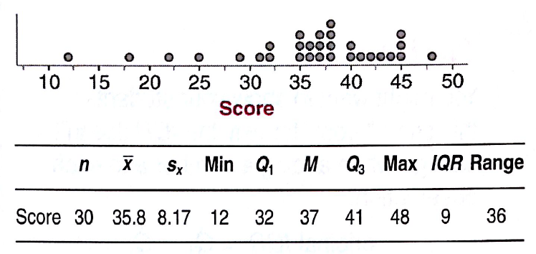 | Suppose that the teacher was nice and added 5 points to each test score. How would this change the shape, center, and spread of the distribution?

Here are the graphs and the summary statistics for the original scores and the +5 scores:
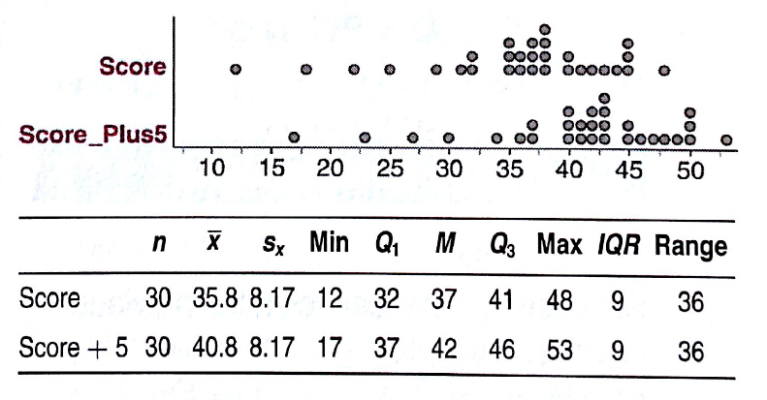

Effect of Adding (or Subtracting) a Constant
Adding the same number a (either positive, zero, or negative) to each observation:
- Adds a to measures of center and location (mean, median, quartiles, percentiles), but
- Does not change the shape of the distribution or measures of spread (range, IQR, standard deviation.

Application: If 24 is added to every observation in a data set, the only one of the following that is not changed is:
(a) the mean (b) the 75th percentile (c) the median (d) the standard deviation (e) the minimum

Example (cont): Suppose that the teacher in the previous example wanted to convert the original test scores to percents. Since the test was out of 50 points, he should multiply each score by 2 to make them out of 100. Here are the graphs and summary statistics for the original scores and the doubled scores.
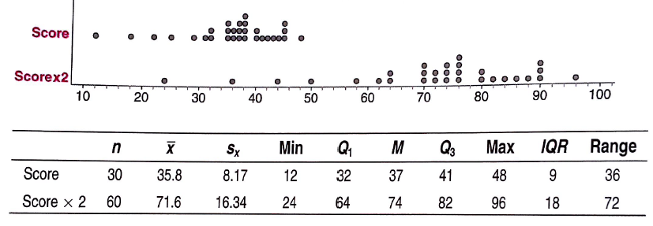
What happened the measures of center, location and spread?
What happened to the shape?
Effect of Multiplying (or Dividing) by a Constant
Multiplying (or dividing) each observation by the same number b (positive, negative or 0)
- Multiplies (divides) measures of center, location (mean, median, quartiles, percentiles) by b,
- Multiplies (divides) measures of spread (range, IQR, standard deviation) by |b|, but
- Does not change the shape of the distribution.

4. Transformations and Z-Scores
Example (continued). Suppose we wanted to standardize the original test scores. This would mean we would subtract each score from the mean of 35.8 and then divide by the standard deviation of 8.17.
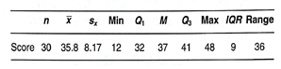
What effect would these transformations have on:
- Shape?

- Center?

- Spread?

Team Work: Complete Check Your Understanding on pp. 97-98
Homework: pp. 107-109, 19, 21, 23, 25-29

