Section 2.2 – Density Curves & Normal Distributions
Density Curves
Exploring Quantitative Data
1. Always plot your data: make a graph, usually a dotplot, stemplot or a histogram.
2. Look for the overall pattern (shape, center, spread) and for striking departures such as outliers.
3. Calculate a numerical summary to briefly describe center and spread.

New step:
4. Sometimes the overall pattern of a large number of observations is so regular that we can describe it with a smooth curve.

This type of smooth curve is called a Density Curve.
Definition: A density curve is a curve that
- Is always above the horizontal axis, and
- Has an area of exactly 1 underneath it
A density curve describes the overall pattern of a distribution. The area under the curve and above any interval of values on the horizontal axis is the proportion of all observations that fall in that interval.
Note: no set of real data is exactly described by a density curve. The curve is an approximation that is easy to use and accurate enough for practical use.
Because the density curve represents a population of individuals, the mean is denoted by μ (the Greek letter mu) and the standard deviation is denoted by σ (the Greek letter sigma).
Distinguishing the Median and Mean of a Density Curve (Diagrams on p. 102)
- The median of a density curve is the equal-areas point, the point that divides the area under the curve in half.
- The mean of a density curve is the balance point, the point at which the curve would balance if made of solid material.
- The median and mean are the same for a perfectly symmetric density curve. The both lie at the center of the curve. The mean of a skewed curve is pulled away from the median in the direction of the long tail.

Team Work: Complete Check Your Understanding on p. 107.

Probably the most famous of all density curves are Normal curves. The distributions they describe are called Normal distributions. They play a very large part in statistics.
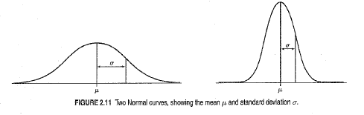
Normal curves have several properties:
- All Normal curves have the same overall shape: symmetric, single-peaked, bell-shaped.
- Any specific Normal curve is completely described by its mean μ and standard deviation σ.
- The mean is located at the center and is equal to the median. Changing μ without changing σ moves the Normal curve along the horizontal axis without changing its shape.
- The standard deviation σ controls the spread of a Normal curve. Normal curves with larger standard deviations are more spread out.
The points at which the Normal curve changes from concave down to concave up occurs one standard deviation from the mean. Because of this, the standard deviation can be estimated by the graph.

Definition: A Normal distribution is described by a Normal density curve. Any particular Normal distribution is completely specified by its mean μ and standard deviation σ. The mean of a Normal distribution is at the center of the symmetric Normal curve and equals the median. The standard deviation is the distance from the center to the inflection points (where concavity changes) on either side.
Notation: We abbreviate the Normal distribution with mean μ and standard deviation σ as N(μ, σ).

The 68-95-99.7 Rule
In a Normal distribution with mean μ and standard deviation σ:  - Approximately 68% of the observations fall within 1 σ of the mean μ.  - Approximately 95% of the observations fall within 2 σ’s of the mean μ.  - Approximately 99.7% of the observations fall within 3 σ’s of the mean μ.  (Note: this rule does not apply to any distribution – only the Normal. Common error on AP Exam.) | 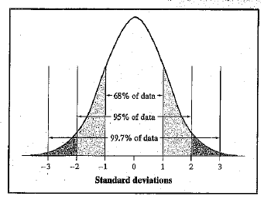
Example: The mean batting average for the 432 Major League Baseball players in 2009 was 0.261 with a standard deviation of 0.034. Suppose the distribution is exactly Normal with μ = 0.261 and σ = 0.034.
a. Sketch a Normal density curve for this distribution. Label the points that are 1, 2, and 3 standard deviations from the mean.

b. What percent of batting averages are above 0.329?
c. What percent of batting averages are between 0.193 and 0.295?

Team Work: Complete Check Your Understanding on p. 112.

The Standard Normal Distribution
Definition: The standard Normal distribution is the Normal distribution with mean 0 and standard deviation 1. If a variable x has any Normal distribution N(μ, σ) with mean μ and standard deviation σ, then the standardized variable $z=\frac{x-μ}{σ}$ has the standard Normal distribution.
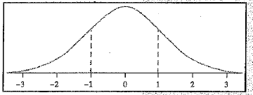 | 68-95-99.7 Rule: For the standard Normal distribution
The standard Normal table is contained in Table A. It is a table of areas under the Normal curve. The table entry for each value z is the area under the curve to left of z. This is also known as the lower tail.
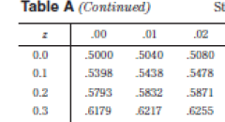
Example: Finding areas under the standard Normal curve.
Use Table A to find the proportion of observations from the standard Normal distribution given the following z-values. Draw a diagram for each.
a. Less than z = -1.25
b. Less than z = 0.81
c. Greater than z = 0.81
d. Between z = -1.25 and z = 0.81

Example: Repeat the previous example using technology.
a. Less than z = -1.25
b. Less than z = 0.81
c. Greater than z = 0.81
d. Between z = -1.25 and z = 0.81

Example: Working backwards…..
Find the 90th percentile of standard Normal distribution
a. Using Table A
b. Using technology

Team Work: Complete Check Your Understanding on p. 116.

Homework: pp. 128 problems 35, 37, 41, 43, 45, 47, 49, 51

